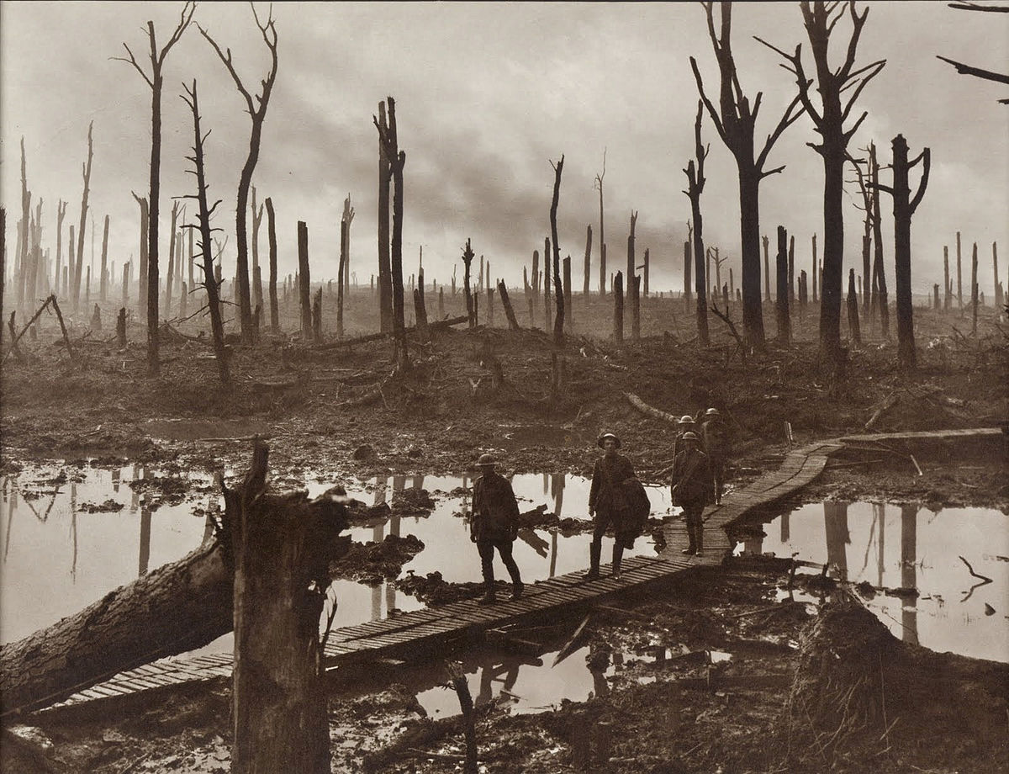
The Battle of Passchendaele, also known as the Third Battle of Ypres, was fought during the First World War from 31 July to 10 November 1917. The battle took place on the Ypres salient on the Western Front, in Belgium, where German and Allied armies had been deadlocked for three years. On 31 July, the British began a new offensive, attempting to break through German lines by capturing a ridge near the ruined village of Passchendaele. After British, Australian and New Zealand troops launched failed assaults, the Canadian Corps joined the battle on 26 October. The Canadians captured the ridge on 6 November, despite heavy rain and shelling that turned the battlefield into a quagmire. Nearly 16,000 Canadians were killed or wounded. The Battle of Passchendaele did nothing to help the Allied effort and became a symbol of the senseless slaughter of the First World War.

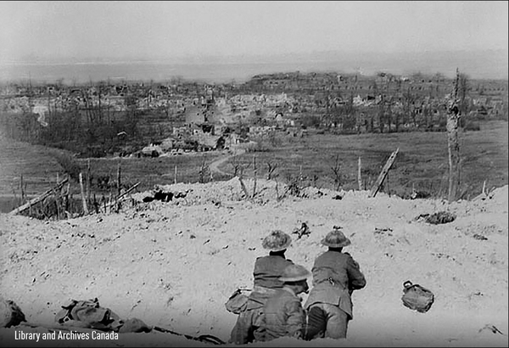
The Battle of Vimy Ridge was fought during the First World War from 9 to 12 April 1917. It is Canada’s most celebrated military victory — an often mythologized symbol of the birth of Canadian national pride and awareness. The battle took place on the Western Front, in northern France. The four divisions of the Canadian Corps, fighting together for the first time, attacked the ridge from 9 to 12 April 1917 and captured it from the German army. It was the largest territorial advance of any Allied force to that point in the war — but it would mean little to the outcome of the conflict. More than 10,600 Canadians were killed and wounded in the assault. Today an iconic memorial atop the ridge honours the 11,285 Canadians killed in France throughout the war who have no known graves.

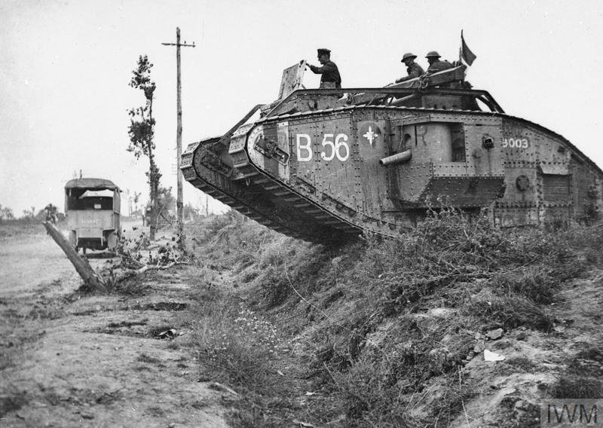
The Battle of Cambrai in northern France took place from 27 September to 11 October 1918, during the First World War. The battle was among the Canadian Corps' most impressive tactical victories of the war, particularly because of the Canadians' skillful use of military engineers. It was part of a series of connected battles at the start of the Hundred Days Campaign, which would lead to the defeat of Germany and the end the war.
On the morning of 27 September the Canadian Corps, with British forces on its flanks, assaulted a dry portion of the partially excavated canal, following in the wake of a moving, or creeping, artillery barrage that kept German defenders down in their dugouts or concrete machine-gun posts. By nightfall, after a day of stiff fighting, the canal had been crossed and secured, and Bourlon Wood captured.
For the next several days the Canadians fended off heavy German counterattacks. Throughout the battle they were assisted over the difficult and often-flooded terrain by engineers who repaired roads and hastily assembled bridges for infantry and artillery.
With Cambrai's outer defences overrun, the city was captured and liberated by the Allies on 11 October.

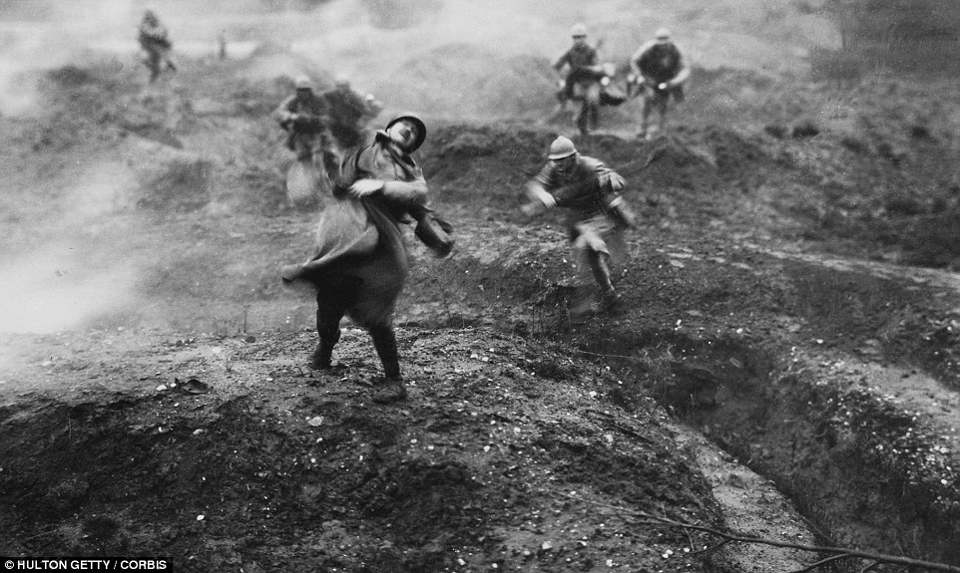

Battle of Verdun, (February 21–December 18, 1916), World War I engagement in which the French repulsed a major German offensive. It was one of the longest, bloodiest, and most-ferocious battles of the war; French casualties amounted to about 400,000, German ones to about 350,000. Some 300,000 were killed.

German Gen. Erich von Falkenhayn believed that the war would be won or lost in France, and he felt that a strategy of attrition was Germany’s best hope of achieving its goals. In a letter to German Emperor William II in late 1915, he argued that Britain was the most formidable of the Allied powers, but he conceded that it could not be assaulted directly, save by submarine warfare, as the British sector of the Western Front did not lend itself to offensive operations (an assessment that would be proved correct at the First Battle of the Somme). In Falkenhayn’s view, Britain’s “real weapons” in the war were the French, Russian, and Italian armies. He regarded Russia as already paralyzed and Italy as unlikely to affect the outcome of the war, concluding, “Only France remains.” Falkenhayn stated that a breakthrough en masse was unnecessary and that instead Germany should bleed France to death by choosing a point of attack “for the retention of which the French would be compelled to throw in every man they have.”

Name: ____________________________________
Exploring Both Primary and Secondary Sources
Battles of WW1
 | Battle of Verdun | Battle of Vimy Ridge | Battle of Passchendaele | Battle of Cambrai
Make inferences about the battle based on the primary source provided.
What questions do you have after looking at the primary source?
After looking at the secondary source, describe the significance of the battle.

