Women’s Suffrage
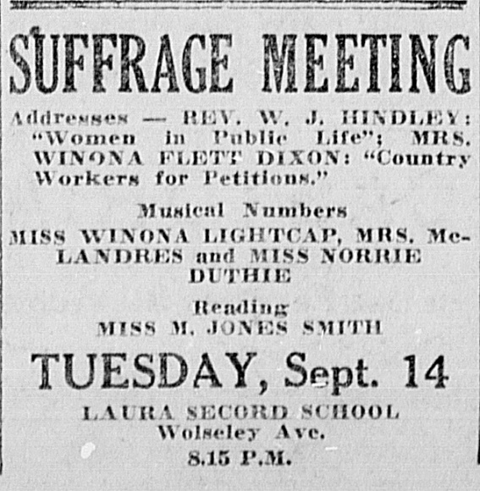
Women’s suffrage (or franchise) is the right of women to vote in political elections; campaigns for this right generally included demand for the right to run for public office.
While they campaigned at every level of government for the vote, suffragists often prioritized local rights. By 1900, propertied women had won some voting rights — including the right to vote and to stand for office in some municipal council, library and school board elections. They next went on to win the right to vote in provincial elections. The first provincial victory occurred in Manitoba on 28 January 1916. In 1940, Québec was the last province to concede the vote.
Federal authorities first granted a limited female franchise in 1917. In 1918, this was expanded to include most women. However, Asian women and men were left out and were not included until after the Second World War. Indigenous women and men living on reserves — and most everywhere else as well — were viewed as wards of the Crown under the Indian Act, and were excluded from the vote across Canada, except in rare cases, until 1960 (see Enfranchisement). After enslavement was abolished in 1834, Black women and men were not formally excluded as a group from the Canadian franchise.
- Why do you believe that women didn’t have the vote when Canada was founded?

- What events/factors do you believe led to the enfranchisement of Canadian women?

Questionnaire:
Answer the following based on your own opinion and understanding of the society that we live in.
 | Yes | No | Unsure
- Do you believe that women can expect to earn less money for the same work as men?
- Are men and women treated equally in the entertainment industry/media?
- 25% of MPs are women. Should there be a law requiring 50% of all MPs be women as some Scandinavian countries have done?
- Have you ever witnessed sexist behavior at your school, workplace, or home?
- Should the government continue to emphasize the importance of having women enter the STEM field?
- Do you believe that we as a society have achieved equality amongst the sexes?
- Have you ever felt discriminated against because of your sex at school, your workplace, or home?
- Do you consider yourself a feminist?
Choose one or two of the questions above and briefly expand on your answer below:
____________________________________________________________________________________________________________________________________________________________________________________________________________________________________________________________________________________________________________________________________________________________________________________________________________

