The United Nations
“We the peoples of the United Nations, determined to save succeeding generations from the scourge of war, which twice in our lifetime has brought untold sorrow to mankind…do hereby establish an international organization to be known as the United Nations.”
Purpose:
- To keep world peace
- Advance justice and law throughout the world
- Defend human rights and promote equality
- Encourage friend relations among nations
 |  | UN Security Council
 |  | 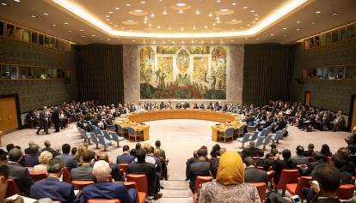
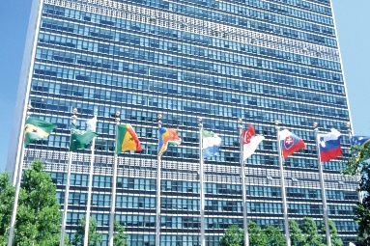 |  | 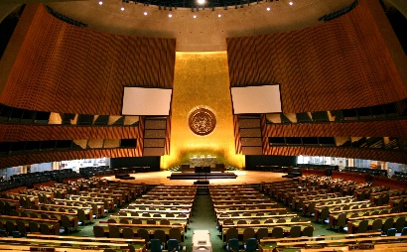 |  | 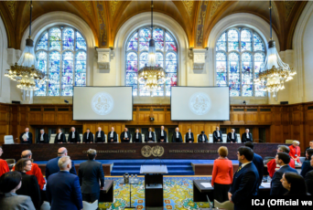
UN Secretariat |  | UN General Assembly |  | UN International Court

Analysis
At the end of WW2, Canada was not one of the “Big Five,” it was only one wrung below. Canada had the world’s third-largest navy, fourth-largest air force, and had 1 million men in uniform.
PM Mackenzie King was able to speak at the UN conference where he argued to more power to be given to the world’s “middle powers.” Due to King’s actions, the UN Charter was changed so that any country that asked to contribute money or troops had to be consulted first.
- Do you believe Canada’s role in the world has increased since the end of the Second World War?

- Should Canada seek a seat on the UN Security Council? (video)

