The Great Upheaval
Expulsion of the Acadians

The Acadians had lived on Nova Scotia’s territory since the founding of Port-Royal in 1604. They established a small, vibrant colony around the Bay of Fundy, building dykes to tame the high tides and to irrigate the rich fields of hay. Largely ignored by France, the Acadians grew independent minded. With their friends and allies the Mi' kmaq, they felt secure, even when sovereignty over their land passed to Britain after the signing of the Treaty of Utrecht in 1713.
- Why were the Acadians so resistant to swearing an oath to the British crown?

- Why was the expulsion of the Acadians an issue of security for the Governor of Nova Scotia and the British settlers living there?

Historical Thinking - The Ethical Dimension
When making ethical judgements, it is important to be cautious about imposing contemporary standards of right and wrong on the past.
When Colonel John Winslow read the deportation order [to the Acadians], he admitted that although it was his duty, it was "very disagreeable to my nature, make and temper." Then added "But it is not my business to animadvert, but to obey such orders as I receive."
Judging this event by contemporary ethical standards we are quick to condemn such actions. Taking Colonel Winslow’s words into account, is it fair for us to criticize the British government’s handling of the Acadians?

Past and Present
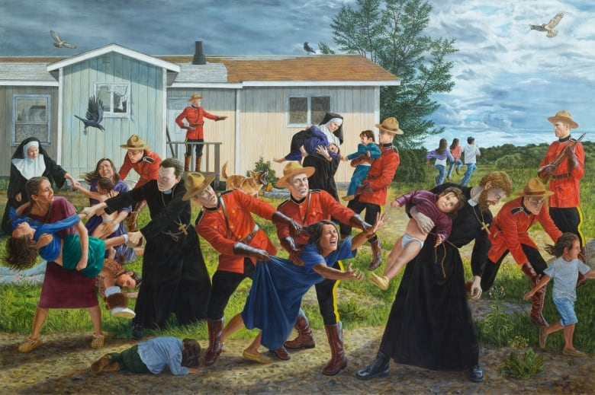
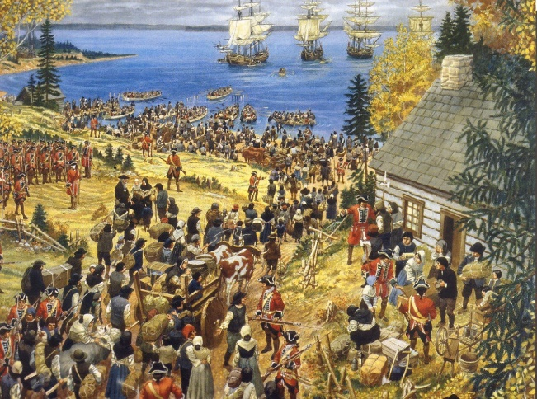
The painting to the left shows the Acadians being forced out of their homes and onto British ships. The one of the right shows an artist’s depiction of the police forcing First Nations children into the residential school system.
- In what ways are these two events similar?

- In what ways are they different?

