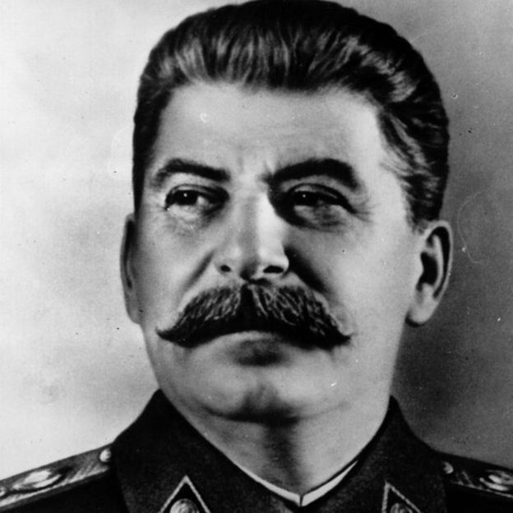
Joseph Stalin

Synopsis
Born on December 18, 1879, in Gori, Georgia, Joseph Stalin rose to power as General Secretary of the Communist Party, becoming a Soviet dictator upon Vladimir Lenin's death. Stalin forced rapid industrialization and the collectivization of agricultural land, resulting in millions dying from famine while others were sent to camps. His Red Army helped defeat Nazi Germany during WWII.

Early Life
On December 18, 1879, in the Russian peasant village of Gori, Georgia, Iosif Vissarionovich Dzhugashvili (later known as Joseph Stalin) was born. The son of Besarion Jughashvili, a cobbler, and Ketevan Geladze, a washerwoman, Joseph was a frail child. At age 7, he contracted smallpox, leaving his face scarred. A few years later he was injured in a carriage accident which left arm slightly deformed (some accounts state his arm trouble was a result of blood poisoning from the injury). The other village children treated him cruelly, instilling in him a sense of inferiority. Because of this, Joseph began a quest for greatness and respect. He also developed a cruel streak for those who crossed him.
Though never a strong orator like Vladimir Lenin or an intellectual like Leon Trotsky, Joseph Stalin excelled in the mundane operations of the revolution, calling meetings, publishing leaflets and organizing strikes and demonstrations. After escaping from exile, he was marked by the Okhranka, (the tsar's secret police) as an outlaw and continued his work in hiding, raising money through robberies, kidnappings and extortion.
In February 1917, the Russian Revolution began. By March, the tsar had abdicated the throne and was placed under house arrest. For a time, the revolutionaries supported a provisional government, believing a smooth transition of power was possible. In April 1917, Bolshevik leader Vladimir Lenin denounced the provisional government, arguing that the people should rise up and take control by seizing land from the rich and factories from the industrialists. By October, the revolution was complete and the Bolsheviks were in control.

Communist Party Leader
The fledgling Soviet government went through a violent period after the revolution as various individuals vied for position and control. In 1922, Stalin was appointed to the newly created office of general secretary of the Communist Party. Though not a significant post at the time, it gave Stalin control over all party member appointments, which allowed him to build his base. He made shrewd appointments and consolidated his power so that eventually nearly all members of the central command owed their position to him. By the time anyone realized what he had done, it was too late. Even Lenin, who was gravely ill, was helpless to regain control from Stalin.
After Lenin's death, in 1924, Stalin set out to destroy the old party leadership and take total control. At first, he had people removed from power through bureaucratic shuffling and denunciations. Many were exiled abroad to Europe and the Americas, including presumed Lenin successor Leon Trotsky. However, further paranoia set in and Stalin soon conducted a vast reign of terror, having people arrested in the night and put before spectacular show trials. Potential rivals were accused of aligning with capitalist nations, convicted of being "enemies of the people" and summarily executed. The purges eventually extended beyond the party elite to local officials suspected of counterrevolutionary activities.
In the late 1920s and early 1930s, Stalin reversed the Bolshevik agrarian policy by seizing land given earlier to the peasants and organizing collective farms. This essentially reduced the peasants back to serfs, as they had been during the monarchy. Stalin believed that collectivism would accelerate food production, but the peasants resented losing their land and working for the state. Millions were killed in forced labor or starved during the ensuing famine. Stalin also set in motion rapid industrialization that initially achieved huge successes, but over time cost millions of lives and vast damage to the environment. Any resistance was met with swift and lethal response; millions of people were exiled to the labor camps of the Gulag or were executed.

Define:

People:  Leon Trotsky  Vladamir Lenin  Joseph Stalin  Tsar Nicholas II | Terms:  Gulag  Cheka  Communism  Industrialization  Collectivization

