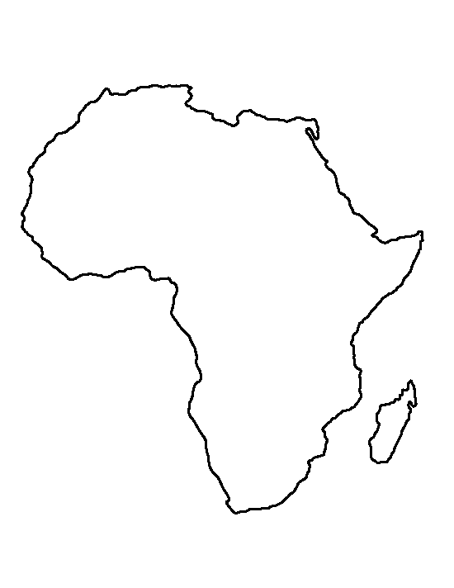
Name: _________________________________________________
Scramble for Africa Assignment

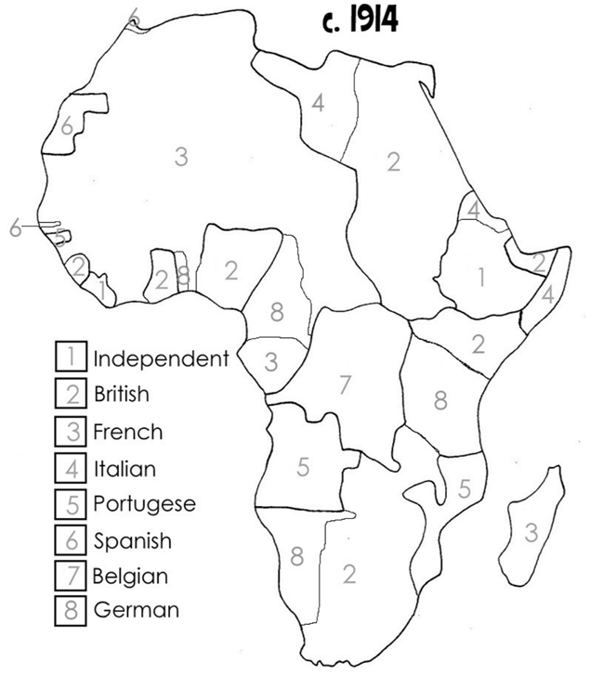
Step1:
- Create a title.

Step2:

- Colour the map of Africa.
- Use the example map provided for you.
- Make sure you create a legend.

Step3:

- Using the areas around the map, answer the following questions using text, images, or a combination of the two.
  - What was the Scramble for Africa?
  - Why were Europeans competing to control the most colonies in Africa?
  - What was the Berlin Conference?
  - What were/are some of the effects of the Scramble for Africa on the Africans?

Grading:

 | 9-10 | 7-8 | 5-6 | 4 or less
Evidence of Understanding  X2 | It is obvious that the student researched each topic carefully and has a strong understanding of the content. | The student researched each topic carefully and has a good understanding of the content. | The student has some understanding of the content. | The student has little understanding of the content.
Layout | The graph is neat and organized. Each event is laid out with purpose and it looks great. | The graph is neat and organized. Each event is laid out with purpose. | The graph is neat and organized. | The graph is either messy or unorganized.

