The Romanov Dynasty
Romanov Palaces
During the 300 year reign of the Romanov family in Russia many grand residences were constructed. Most of these are found near St. Petersburg and Moscow and still stand to this day. Today they serve as government buildings, museums and tourist attractions.

In your group, discuss the following questions:
Which of these palaces is most impressive? Explain.
What do these palaces tell you about the Russian royal family?
Is this a primary or secondary source? Explain.

Grand Peterhof Palace
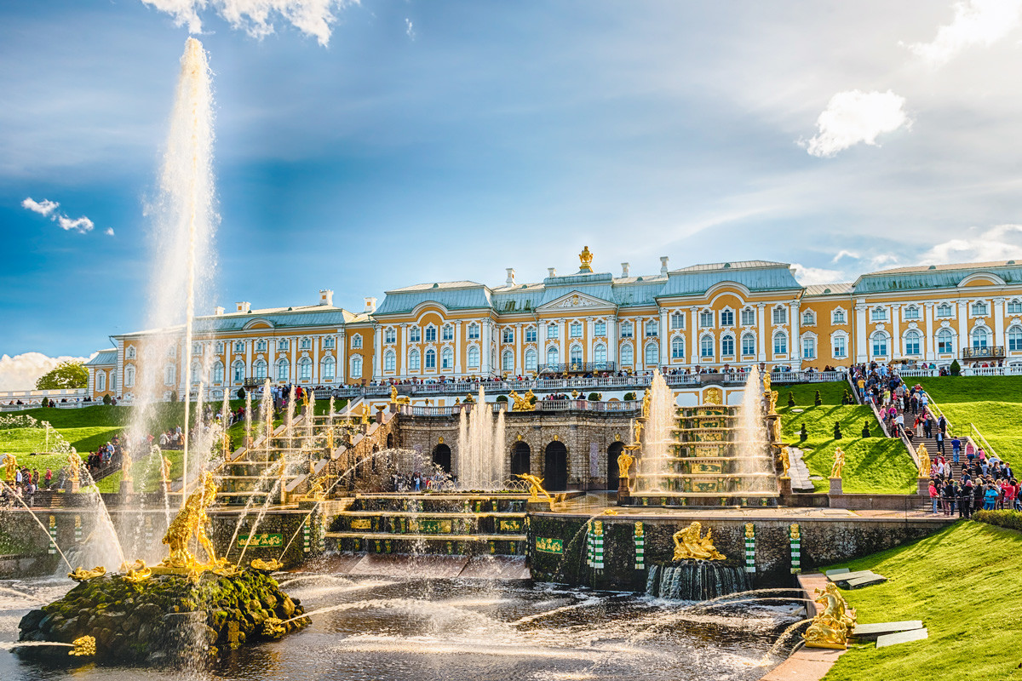
\
The Grand Peterhof Palace is a true gem of Peterhof, a complex of palaces and gardens near St. Petersburg. Here, in Peterhof, known also as “the Russian Versailles,” Russian Emperors had their country residence. Nowadays, the palace is a museum, which contains over 3,500 exhibits: paintings, porcelain, fabrics, furniture, and personal belongings of the Russian rulers. The Peterhof complex also consists of several minor palaces. In one of them - the Farm Palace - the first elevator in Russia was installed.

Winter Palace
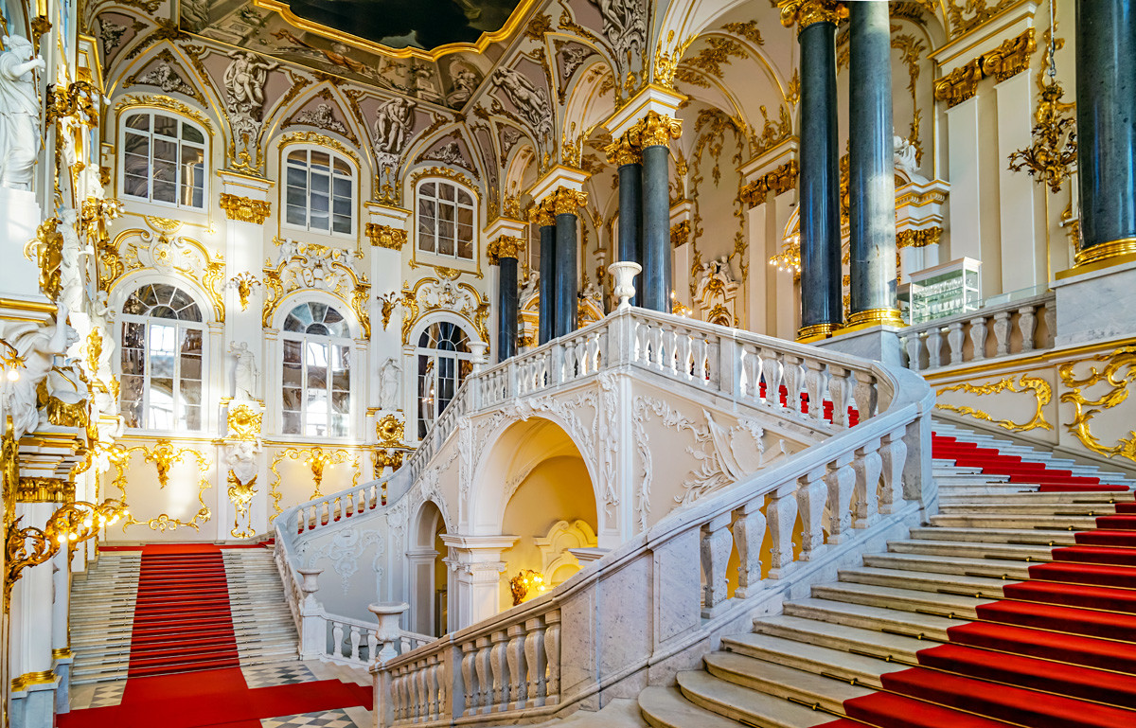
The main residence of the Russian Emperors, the Winter Palace impresses by its sheer vastness. It has 1,057 rooms, 1,786 doors, 1,945 windows and 117 staircases. Its halls are decorated with 176 sculptures. Today, the Winter Palace is the main home to the Hermitage Museum. Within its wall visitors may find millions of exhibits from the prehistoric era to our days, including well-known works by Leonardo da Vinci, Henri Matisse and Rembrandt.

Catherine Palace (Leningrad Region)
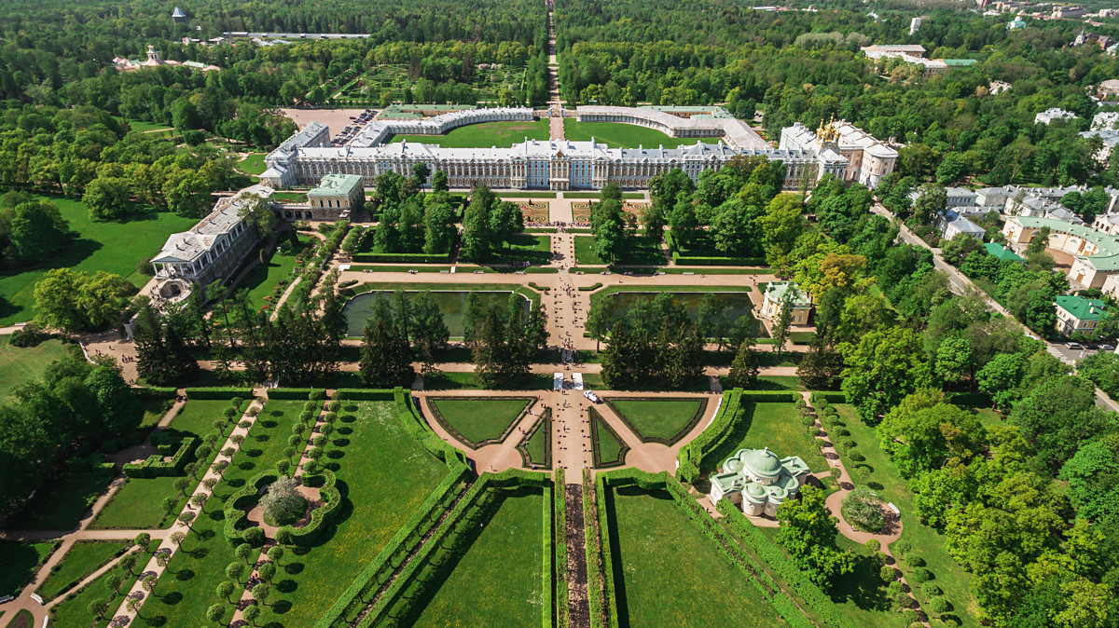
Three Empresses - Catherine I, Elizabeth Petrovna and Catherine II - spared no money and effort to make it one of the most beautiful palaces in Europe. The most remarkable feature in the Catherine Palace is the Amber Room, whose panels and decorations are made of amber. Presented to the Russian Tsar Peter I by Frederick Wilhelm I of Prussia, it was lost without a trace during World War II. Now visitors may see a restored version of the masterpiece.

Konstantin Palace (St. Petersburg)
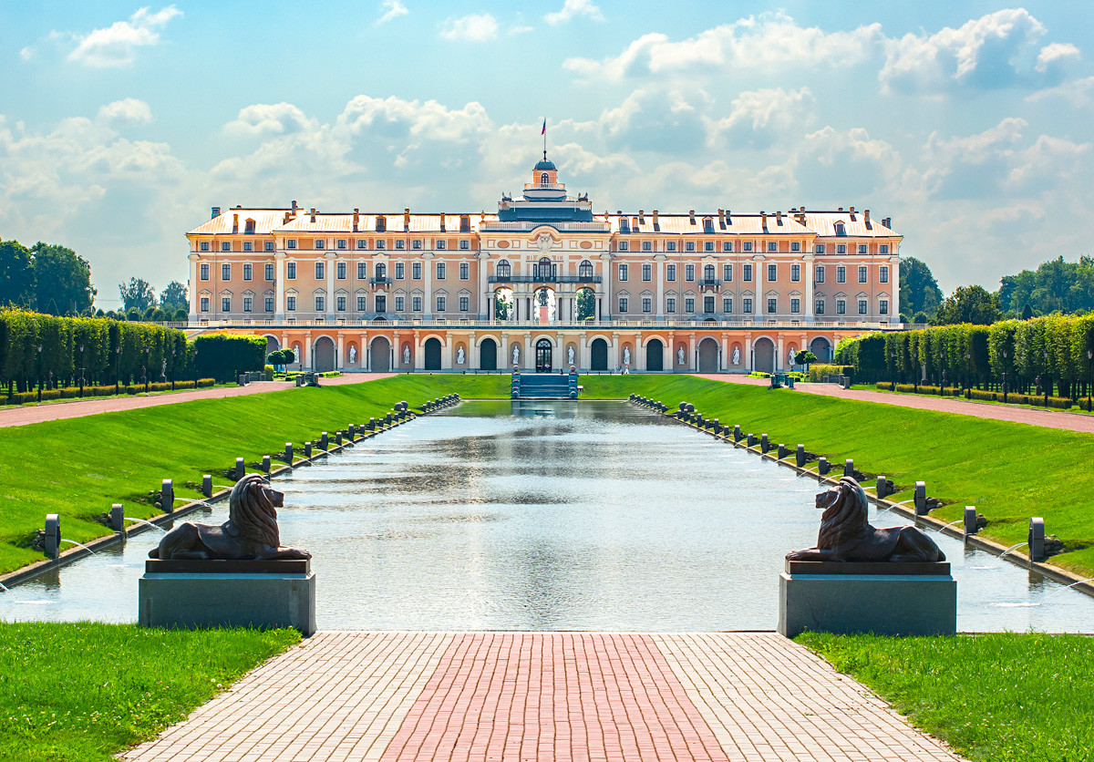
The Konstantin Palace today is the business and cultural center of St. Petersburg. Major events such as Russia-EU and G20 Summits take place here now.

