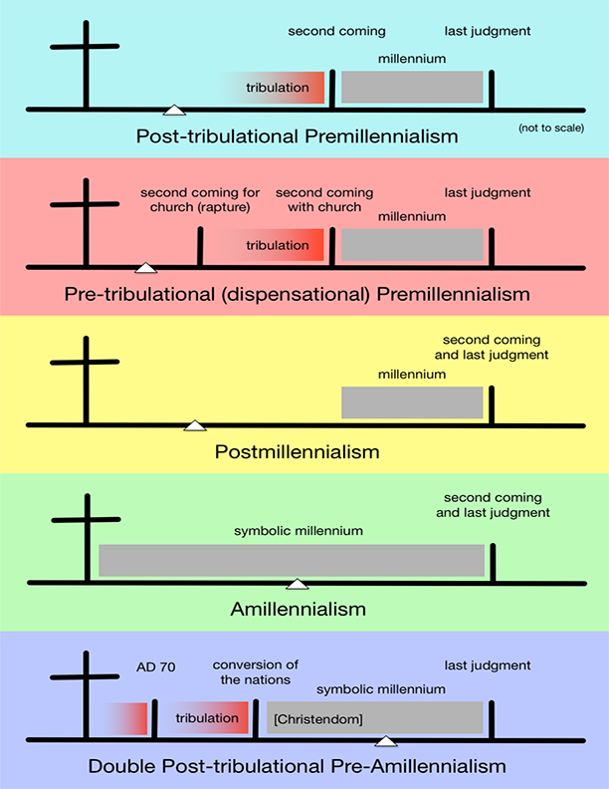

The Rapture, Millennial Kingdom, and Second Coming of Christ

- Which of the views indicated on the other side of this page is an example of the…
  - Preterist view: __________________________________________
  - Historicist view: _________________________________________
  - Futurist view: ___________________________________________
  - Idealist view: ___________________________________________

- Do you know which of these views are taught in your church? Your home? If you’re not sure, provide your best guess.

- Pastor David is teaching from an amillennial view of Revelation. Have you like about this view so far? What questions/concerns do you have about this view?

- Is it important to decide on one of these views of the end times? Explain.

