Daniel’s Seventy Weeks
Daniel 9

Read Daniel 9:24-27
The following chart lays out the description of the seventy weeks from Daniel along with a few options regarding the most likely interpretations of this text.
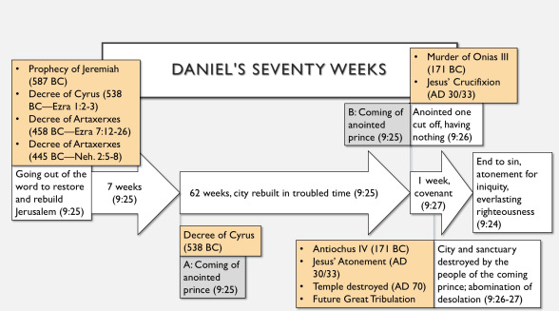

Pre-tribulational Premillennial View:
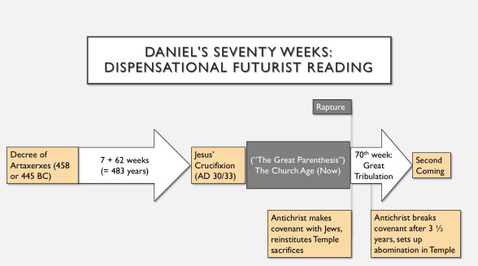
Amillennial View (Postmillennial):
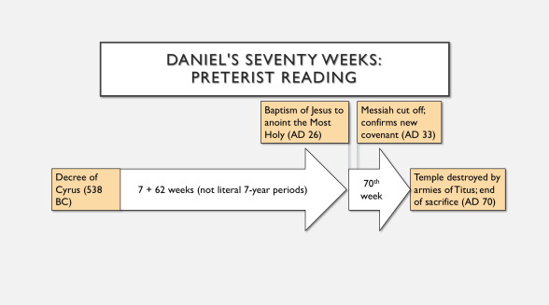
At this time, which of these views of Daniel’s 70 weeks do you find more persuasive? Explain.
____________________________________________________________________________________________________________________________________________________________________________________________________________________________________________________________________________________________________________________________________________________

