**Moving Toward Equality and Liberty**

**Step 1:**

Define each of the terms below the titles. Make sure the definitions are specific to the time period and theme that we are researching.

**Step 2:**

Choose ONE character from either the Renaissance or the Enlightenment as a topic of study. You will find the instructions for this project on the back of this handout.

**Themes of the Renaissance (~1300-1600)**

* humanism –
* rationalism –

|  |  |
| --- | --- |
| Leonardo da Vinci  Galileo Galilei  Nicolaus Capernicus  Thomas More | Petrarch  Niccolo Machiavelli  Wolfgang Amadeus Mozart |

**Themes of the Enlightenment (~1685-1815)**

* scientific method –
* utilitarianism –
* constitutionalism –

|  |  |
| --- | --- |
| Francis Bacon  Rene Descartes  John Locke  Voltaire | Jean-Jacques Rousseau  David Hume  Adam Smith  Immanuel Kant |

**Cube Research Project**

You will be researching your historical figure using the following format:

Keep note the direction of each block of information on the cube.

Answer ONE of the following:

Should the rights of the individual or the group have higher priority?

Should some people be given more power and privilege than others?

Is the use of force ever justified in a conflict over social change?

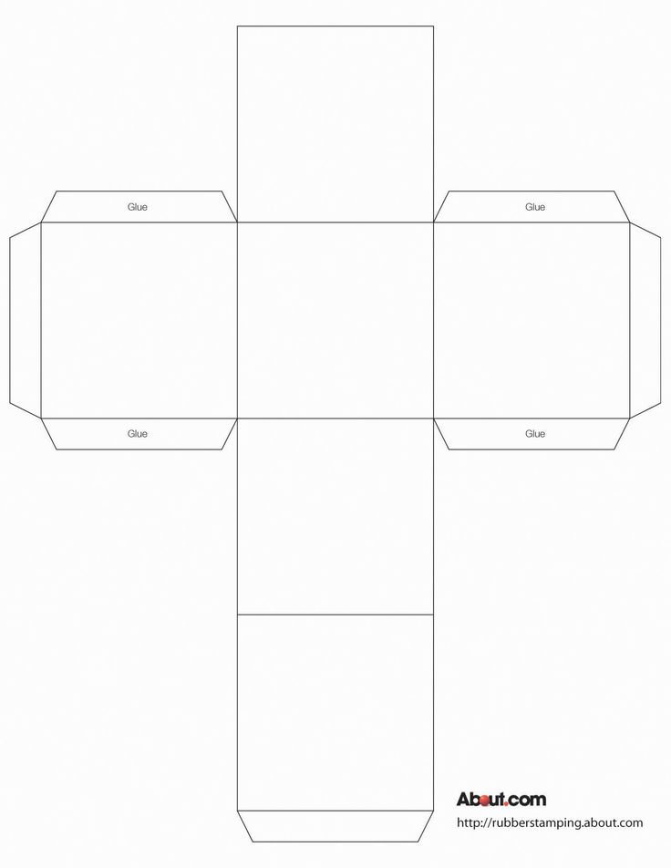

Choose one Renaissance or Enlightenment idea and explain its value in modern society.

How has your historical figure contributed to modern day society/ideas?

Quote

Picture of the

Historical Figure

Name:

Date of Birth:

Place of Birth:

Education:

Famous Works:



|  |  |  |  |  |
| --- | --- | --- | --- | --- |
|  | 9-10 | 7-8 | 5-6 | -5 |
| Neatness/Organization | The project is neat, organized, and creative. There is a considerable amount of information included in the project, but it doesn’t appear cluttered. | The project is neat, organized, and creative. | The project is neat, organized, or creative. | The project fails to be neat, organized, or creative. |
| Required Elements | All of the required elements are included, and there is some evidence of extra work | All of the required elements are included | Most of the required elements are included | Many of the required elements are missing |