Making a Law
Understanding how a law is made in Canada is integral to understanding the Canadian legal process.
The class will be split into two groups (political parties). Your first step will be to canvas your constituents (the school) to see what type of law they would like. You will then follow the steps below to see your bill become a law.
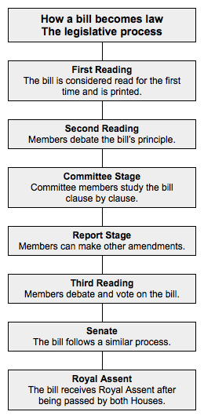

Read your bill to the class.

Bill is debated.
After debate you will examine the bill and consider changes.
Report the changes that you have made to the bill.
Read and debate the bill. Following this stage, there will be a vote.

HOUSE OF COMMONS OF CANADA
BILL C-_______
An Act to _______________________________________________

FIRST READING, __________ ___, 20___

SUMMARY
______________________________________________________________________________________________________________________________________________________________________________________________________________________________________________________________________________________________________________________________________________________________________________

HOUSE OF COMMONS OF CANADA
BILL C-_______

An Act to _____________________________________________________

Her Majesty, by and with the advice and consent of the Senate and House of Commons of Canada, enacts as follows:

