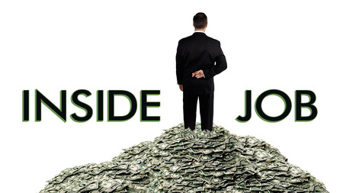
- List some of the causes of the 2008 financial crisis:

- What is deregulation?

- What does the phrase “too big to fail” refer to?

- Describe the analogy of the oil tanker as it relates to the financial crisis?

- What are derivatives?

- What changed about how mortgage payments are made?

- What is a AAA rating?

Part II: The Bubble
- What does the housing bubble refer to?

- How was this all like a Ponzi scheme?

Skip 46:00-47:35
- What is the problem with people owing 99% of the value of their home?

Skip 51:40-54:00

