Industrial Arts Safety Test
You must get at least 75% on this test to be allowed to work in the shop. Test is out of 65 so you need 49 correct.
Section A – Fill in the blank with the word you feel best suits the sentence from the bank of words below.

yourself | experienced | others | attitude | permission | help

- It is important to study safety so that you do not injure _______________ or _______________.
- Always have a good _______________ towards safety.
- Most accidents in the shop happen to _______________ woodworkers.
- Never be afraid to ask for _______________.
- Never use a machine on your own until you have _______________ to do so.

Equipment | removed | others | organized | pocket | confidence

- Failure to follow safety rules may result in damage to _______________ or _______________.
- Students who do not follow the rules may be _______________ from working in the IA lab.
- Keep your tools and materials carefully _______________.
- Do not put tools in your _______________.
- As you work with the tools you will gain _______________.

Thoughtful | Flammable | Helpful | Turned off | litter | Safety glasses

- Be _______________ and _______________ to others.
- Before plugging in tools make sure they are _______________.
- Always wear _______________ when working with tools.
- Many finishers and thinners are highly _______________.
- Keep the floor clear of scrap wood and _______________.

Tied back | Awkward | remove | Injuries | teacher

- Long hair should be _______________ in the shop.
- Report all _______________ to the teacher.
- Get help with heavy and _______________ things when you are carrying them.
- Never _______________ a safety guard.
- Do not use tools in the shop unless the _______________ is there.

Rush | Tool | Blades | ill | defects | tired

- Use the correct _______________ for the job.
- Keep a safe distance away from _______________.
- Check for _______________ in wood before cutting.
- Do not _______________ your work.
- Never work in the shop if you are overly _______________ or _______________.

Not working | Teeth | distracted | Corners | bit

- Do not be _______________ while you are working.
- If your machine appears to be _______________, stop and get the teacher.
- Feed the band saw only as fast as the _______________ can cut.
- Avoid cutting tight _______________ with the bandsaw.
- Use the correct _______________ when drilling.

Withdraw/remove | With the | Sealed | hole | up

- When drilling deep holes be sure to _______________ the bit frequently.
- Store all chemicals and soiled rags in a _______________ container.
- Make a _______________ before making an internal cut with a jigsaw.
- The teeth on a jigsaw should point _______________.
- On a jointer always feed _______________ grain.

Securely | Sharp | Dry | Against | thickness

- Make sure jointer blades are _______________.
- Make sure glue is completely _______________ before turning it on the lathe.
- Fasten stock _______________ before turning on the lathe.
- Never plane _______________ the grain.
- Do not feed wood of different _______________ through the planer at the same time.

Side | speed | Small | firmly | one

- When cutting with a circular saw stand to the _______________.
- Hold a drill _______________ while using it.
- Never sand pieces of wood that are _______________.
- Make sure a mitre saw reaches full _______________ before cutting.
- Cut only _______________ piece of wood at a time on a mitre saw.

operator | point | Free hand | ask | pull

- Never cut _______________ on a table saw.
- The _______________ controls the speed of a cut on a table saw.
- Never _______________ an air nailer at something you don’t want to nail.
- Never _______________ the compressor by the hose.
- When in doubt, _______________.

Section B – Tool Identification
Label each tool:
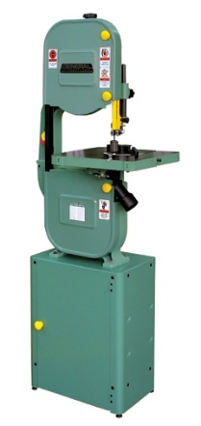  jig saw band saw drill press | _____________________________
 | _____________________________
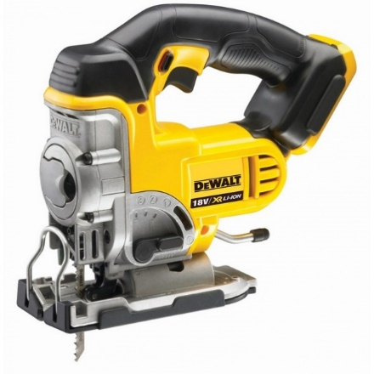 | _____________________________
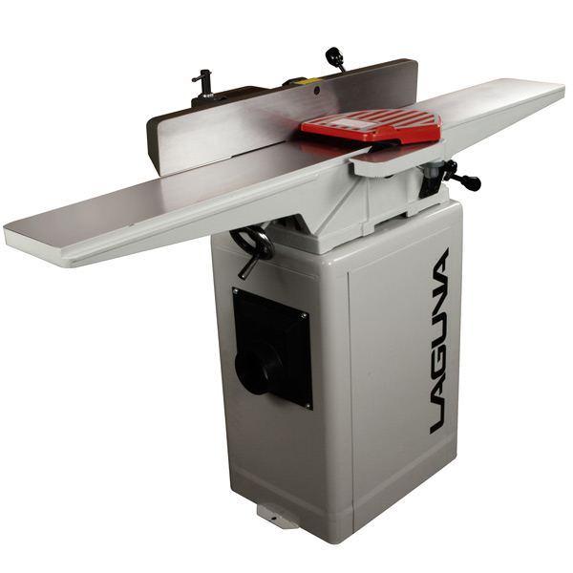  lathe planer jointer circular saw | _____________________________
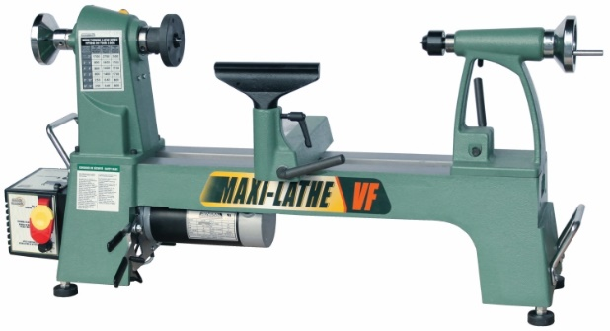 | _____________________________
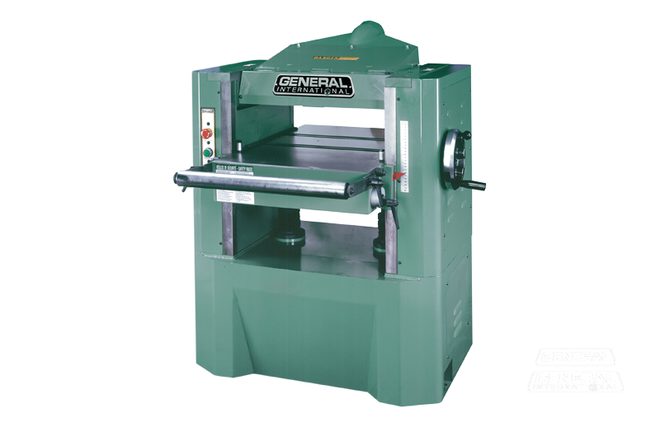 | _____________________________
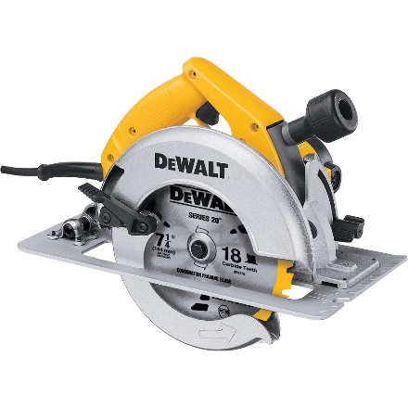 | _____________________________
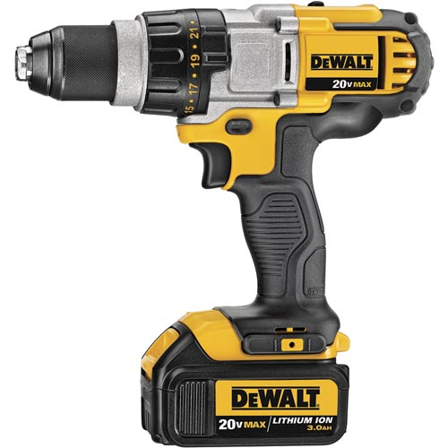  router drill sander scroll saw | _____________________________
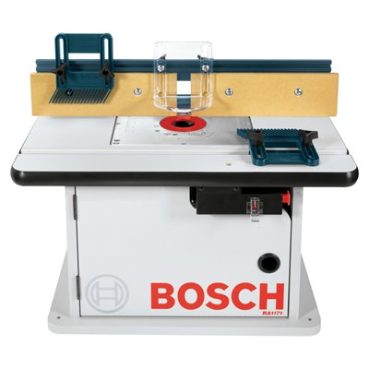 | _____________________________
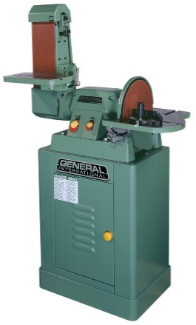 | _____________________________
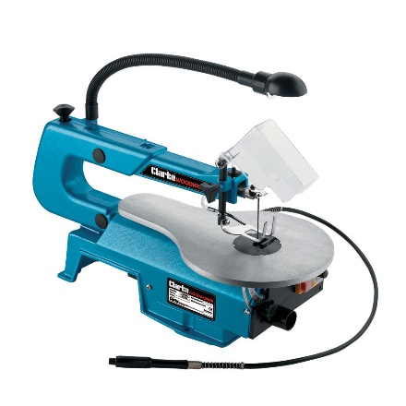 | _____________________________
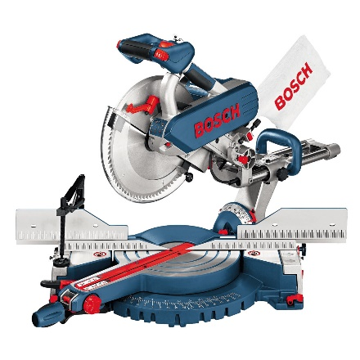  mitre saw table saw grinder air nailer | _____________________________
  

