Industrial Arts Safety Test (Key)
You must get at least 75% on this test to be allowed to work in the shop. Test is out of 65 so you need 49 correct.
Section A – Fill in the blank with the word you feel best suits the sentence from the bank of words below.
across | down | helpful | people | side | tool
approval | down | hole | pocket | small | turned off
ask | dry | ill | point | speed | up
attitude | equipment | injuries | properly sealed | speed | with the
awkward | excluded | litter | pull | teacher | withdraw
blades | experienced | malfunctioning | remove | teeth | yourself
confidence | firmly | one | rush | thickness
corners | flammable | operator | safety glasses | thoughtful
defects | free hand | organized | securely | tied back
distracted | help | others | sharp | tired

- It is important to study safety so that you do not injure yourself or others
- Always have a good attitude towards safety.
- Most accidents in the shop happen to experienced woodworkers.
- Never be afraid to ask for help
- Never use a machine on your own until you have approval to do so.
- Failure to follow safety procedures and guidelines may result in damage to equipment or
people
- Students who do not follow safety guidelines may be excluded from working in the IA lab.
- Keep your tools and materials carefully organized
- Do not put tools in your pocket
- As you work with the tools you will gain confidence
- Be helpful and thoughtful to others.
- Before plugging in tools make sure they are turned off.
- Always wear safety glasses when working with tools.
- Many finishers and thinners are highly flammable
- Keep the floor clear of scrap wood and litter
- Long hair should be tied back in the shop.
- Report all injuries to the teacher.
- Get help with heavy and awkward things when you are carrying them.
- Never remove a safety guard.
- Do not use tools in the shop unless the teacher is there.
- Use the correct tool for the job.
- Keep a safe distance away from blades
- Check for defects in wood before cutting.
- Do not rush your work.
- Never work in the shop if you are overly tired or ill
- Do not be distracted while you are working.
- If your machine appears to be malfunctioning stop and get the teacher.
- Feed the band saw only as fast as the teeth can cut.
- Avoid cutting tight corners with the bandsaw.
- Use the correct speed when drilling.
- When drilling deep holes be sure to withdraw the bit frequently.
- Store all chemicals and soiled rags in a properly sealed container.
- Make a hole before making an internal cut with a jigsaw.
- The teeth on a jigsaw should point up
- On a jointer always feed with the grain.
- Make sure jointer blades are sharp
- Make sure glue is completely dry before turning it on the lathe.
- Fasten stock securely before turning on the lathe.
- Never plane across the grain.
- Do not feed wood of different thickness through the planer at the same time.
- When cutting with a circular saw stand to the side
- Hold a drill firmly while using it.
- Never sand pieces of wood that are small
- Make sure a mitre saw reaches full speed before cutting.
- Cut only one piece of wood at a time on a mitre saw.
- Never cut free hand on a table saw.
- The operator controls the speed of a cut on a table saw.
- Never point an air nailer at something you don’t want to nail.
- Never pull the compressor by the hose.
- When in doubt, ask

Section B – Tool Identification
Label each tool
Air Nailer | Hand Drill | Planer
Bandsaw | Jigsaw | Router Table
Circular Saw | Jointer | Sander
Drill Press | Lathe | Scroll Saw
Grinder | Mitre Saw | Table Saw

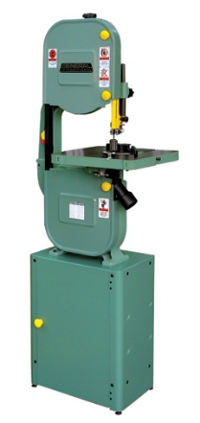 | Bandsaw
 | Drill Press
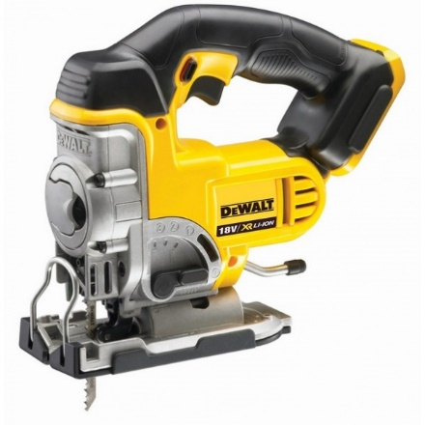 | Jigsaw
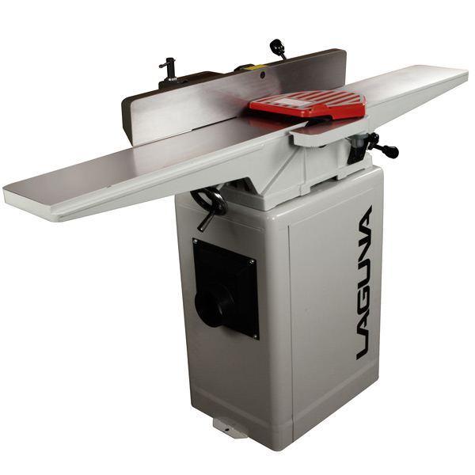 | Jointer
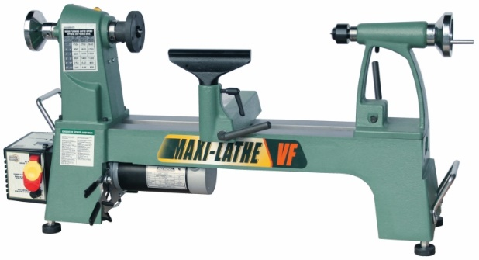 | Lathe
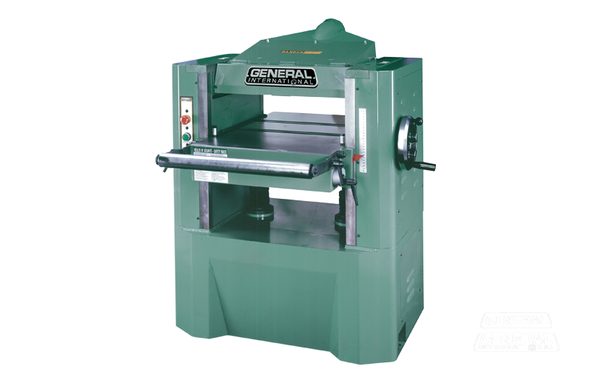 | Planer
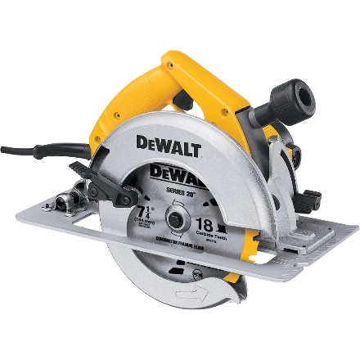 | Circular Saw
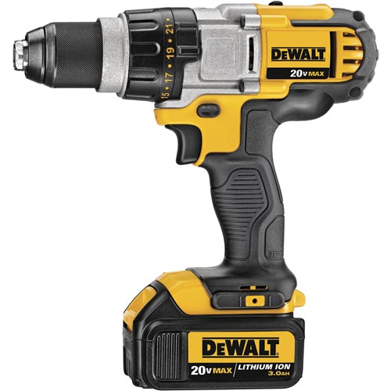 | Drill
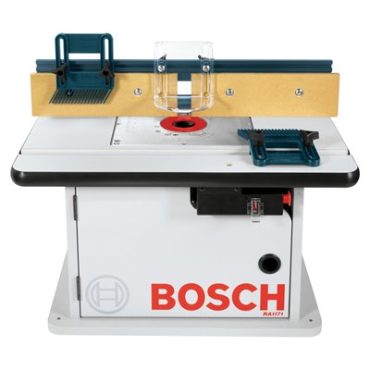 | Router
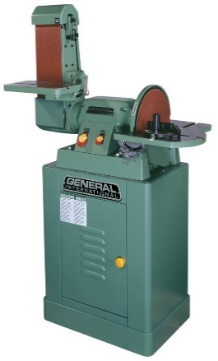 | Sander
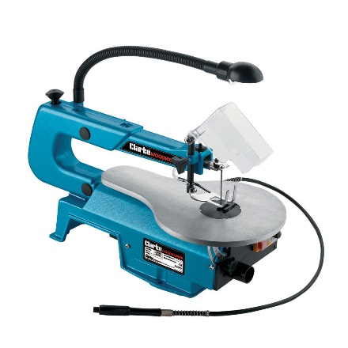 | Scroll Saw
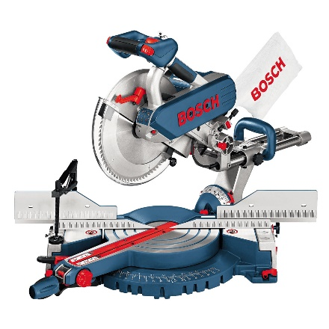 | Mitre Saw
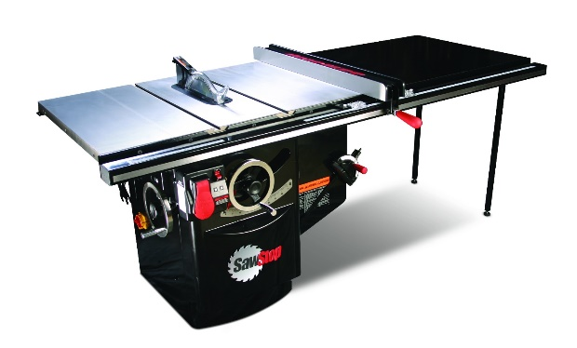 | Table Saw
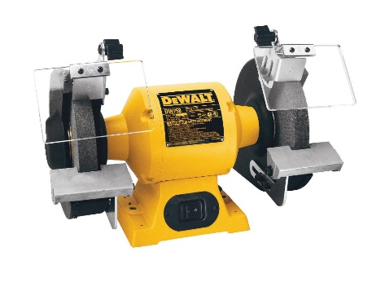 | Grinder
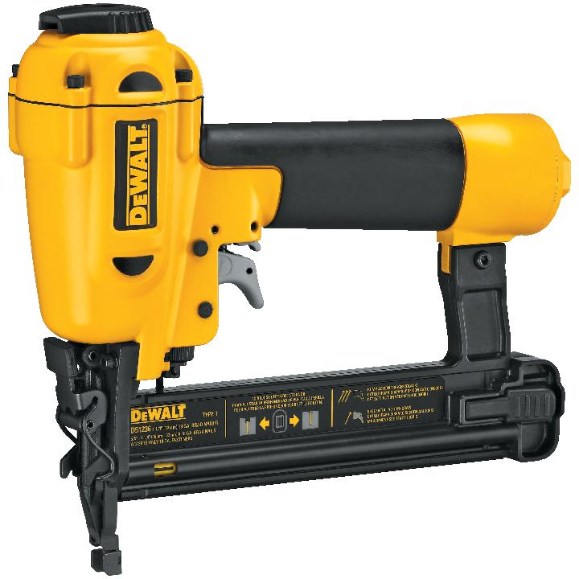 | Air Nailer

