The Romanov Dynasty
Faberge Eggs
Faberge eggs were jeweled eggs created by the jewelry firm House of Fabergé, in Saint Petersburg, Russian Empire. Possibly as many as 69 were created, of which 57 survive today. Virtually all were manufactured under the supervision of Peter Carl Fabergé between 1885 and 1917. The most famous are his 52 "Imperial" eggs, 46 of which survive, made for the Russian Tsars Alexander III and Nicholas II as Easter gifts for their wives and mothers.

In your group, discuss the following questions:
Which of these eggs is most impressive? Explain.
What do these ‘gifts’ tell you about the Russian royal family?
Is this a primary or secondary source?

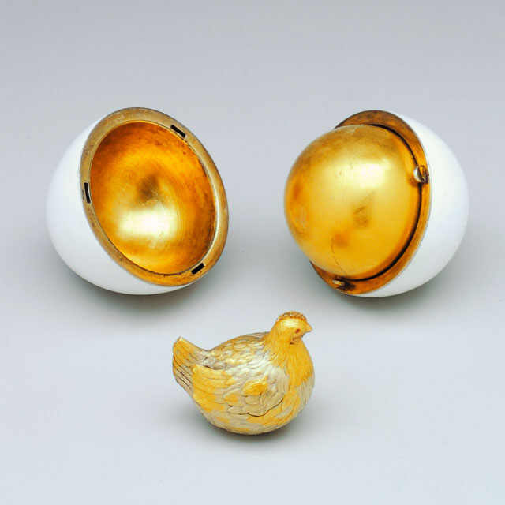
Image courtesy of the Forbes Collection
The Hen Egg, 1885
Inspired by an 18th century original, the Hen Egg has an opaque white enamelled outer ‘shell’, opening with a twist to reveal a first surprise - a matt yellow gold yolk. This in turn contains an enamelled chased gold hen that once held a replica of the Imperial Crown with a precious ruby pendant egg within. The drop by itself cost more than half of the egg’s total price (both lost, being only known from an old photograph).

Renaissance Egg, 1894
Presented by Emperor Alexander III to his wife, Maria Feodorovna, this Renaissance style object was inspired by an oval agate casket by Le Roy in the Dresden Grünes Gewölbe (Green Vaults), the museum founded by Augustus the Strong in 1723. Cleverly transformed by Fabergé into an egg shape, it is made of cloudy agate, its cover applied with opaque white enamel gold trellis-work with a quatrefoil of diamonds and a ruby centre at each intersection. A red enamel band divides the two egg-halves. The top bears the date 1894 set in rose diamonds. This exact, artfully modified copy, is proof that Fabergé actually handled some of the works in the Green Vaults.
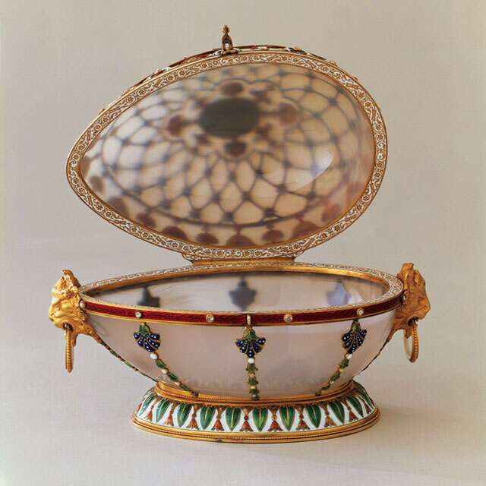
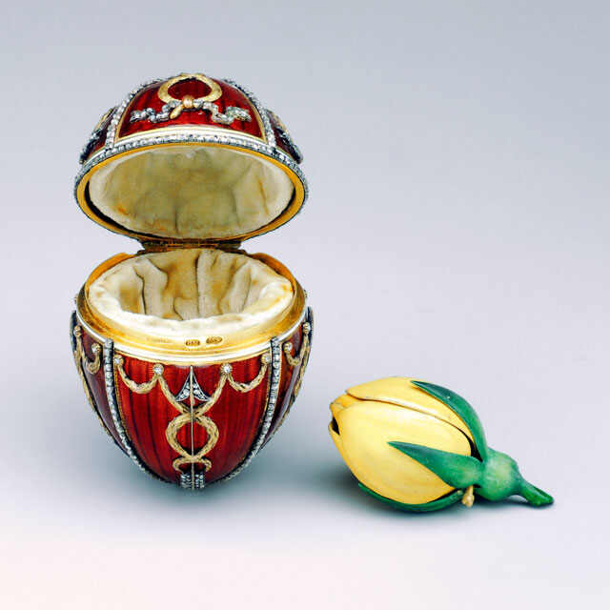
Image courtesy of the Forbes Collection
Rosebud Egg, 1895
This egg, applied with diamond-set Cupid’s arrows symbolizing Love, was the first of the series presented by Emperor Nicholas II to his wife, Empress Alexandra Feodorovna, a few months after their marriage. It is crafted from multi-coloured gold, decorated with bands of rose-cut diamonds and is covered with translucent red guilloché enamel. The rosebud surprise is of opaque yellow and green enamel. At its apex the egg has a miniature portrait of the young Emperor under a table-cut diamond, and at its base the date 1894. Further surprises contained within, a diamond-set crown and a ruby drop, are only known from an old photograph.

Coronation Egg, 1897
This, perhaps Faberge’s most iconic egg, was presented by Emperor Nicholas II to his wife, Empress Alexandra Feodorovna, as a memento of her entry into Moscow on May 26th, day of their Coronation in the Uspensky Cathedral. Its outer shell is made of multi-coloured gold, embellished with translucent yellow guilloché enamel and black enamel double-headed eagles set with diamonds, a design recalling the heavy Cloth of Gold robe she wore at the ceremony. The jewelled monogram of the empress appears at the egg’s apex under a portrait diamond, with the date at the base. The egg opens to reveal a surprise in the form of a diamond-set enamelled gold miniature replica of the original 18th century carriage by Buckendahl which once contained an emerald drop, later replaced by a yellow briolette diamond (both lost). The 3 11/16 in. (9.4cm) coach took craftsman, Georg Stein 13 months to complete. It is currently valued at $18,000,000.
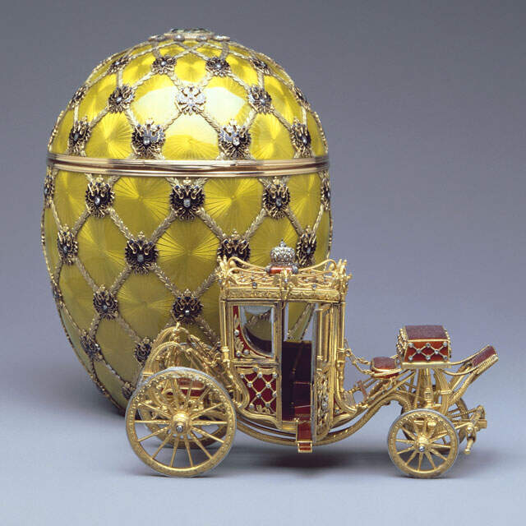
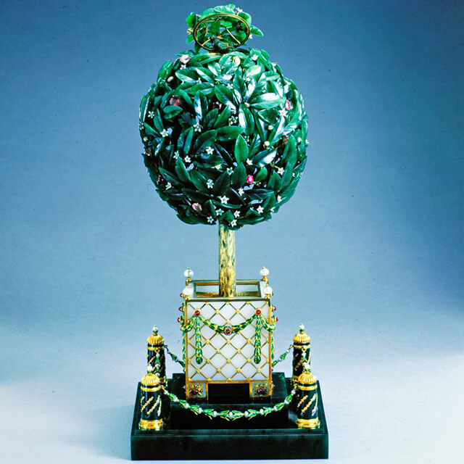
Image courtesy of the Forbes Collection
Bay-Tree Egg, 1911
The egg, presented by Emperor Nicholas II to his mother, Dowager Empress Maria Feodorovna, is inspired by a French 18th century singing bird automaton. According to the Fabergé invoice, the bay tree comprises “325 nephrite leaves, 110 opalescent white enamel flowers, 25 diamonds, 20 rubies, 53 pearls, 219 rose-cut diamonds and one large rose-cut diamond”. When the clockwork automation is wound up and set in motion, a feathered bird appears, flaps its wings, turns its head, opens its beak and sings.

