WORLD WAR ONE: 1918
- What government has signed an armistice with the Central Powers in 1918?
- Germany faces inevitable defeat, unless it can win a quick victory on the ___________ Front.
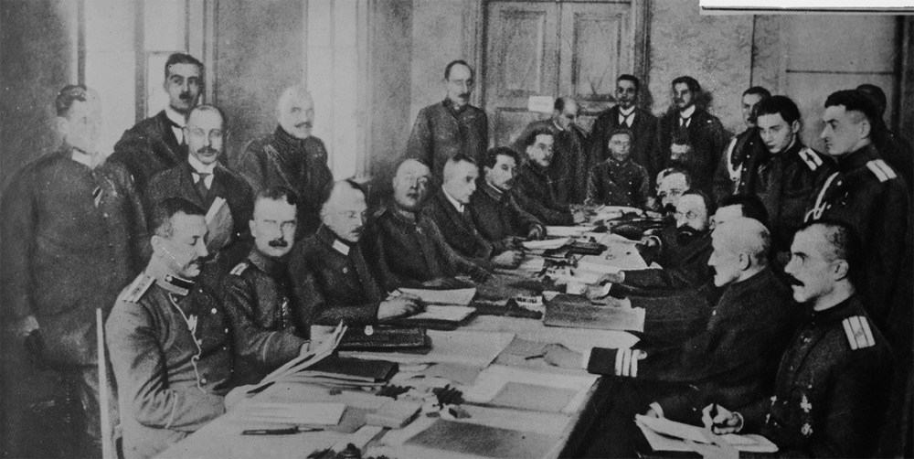
- 8 January - US President Wilson announces his 'Fourteen Points'. They outline his vision for a post-war world, including an end to secret _________________, a reduction in the size of armed forces, ______________________________ for the people of the Austro-Hungarian Empire, and an international organisation to settle _______________ disputes.
- 3 March - What does Russia give up in exchange for peace?

- Why have the Allies won air superiority over the Germans?

- How many victories did the ‘Red Baron’ have and what happened to him near Amiens?

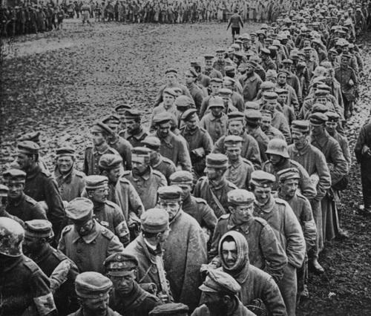
- 15 July - On the Western Front, the Germans' final attack is defeated in the Second Battle of the Marne. How many German Casualties? _______________________
- 8 August - The Allies now go on the attack. German troops are exhausted, hungry and demoralised, and begin to _______________________ in their thousands. Trench warfare is over; the Germans are in full ____________________
- 4 October - Ludendorff informs the Kaiser that the military situation is hopeless, and that Germany must seek an ________________.

- 11 November -What did Germany do on November 11th?

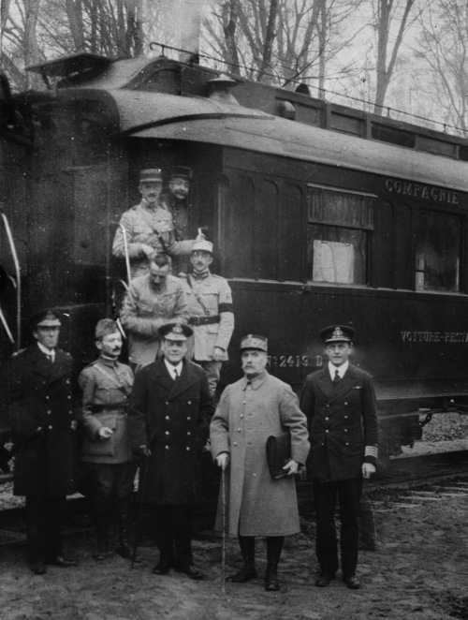
- 18 January 1919 - The Paris Peace Conference opens at the Palace of Versailles, just outside the French capital. Delegates accept a proposal to create a '_____________________________’ to settle future international disputes.
- 4 June - The Versailles Treaty is signed. |t imposes harsh terms on Germany: List 3 things Germany had to do:
- The boundaries of Europe are redrawn: ________________ re-emerges after a hundred years of foreign rule.
- What Empire is dismantled? ________________________________
- How many soldiers were killed in WWI? ___________________________
- How many civilians were killed? ________________________

