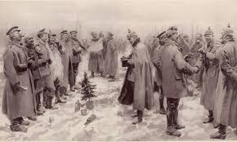
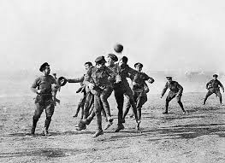

WORLD WAR ONE - 1915
- January 1915. World War One is just five months old, and already around _________ million soldiers have fallen.
- Austro-Hungarian troops have also suffered huge losses, and are humiliated by their failure to defeat ____________________.
- While on the Western Front, French, British and Belgian troops are dug in facing the Germans, in ________________stretching from the English Channel to Switzerland.
- 19th January: As part of the world’s first strategic bombing campaign, Germany sends two giant airships, known as __________________________, to bomb Britain.
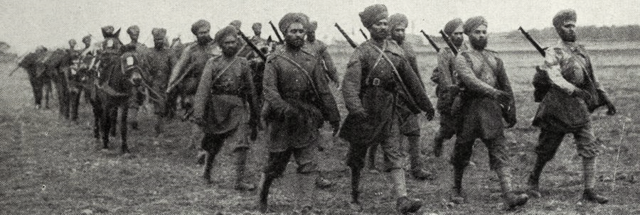
- 7th February: On the Eastern Front, German Field Marshal von Hindenburg launches a Winter Offensive, and inflicts another massive defeat on the Russian army at the Second Battle of Masurian Lakes. The Russians lose up to______________men, half of them surrendering amid freezing winter conditions.
- 10th March: On the Western Front, the British attack at Neuve Chapelle, but the advance is soon halted by German barbed wire and _________________________.
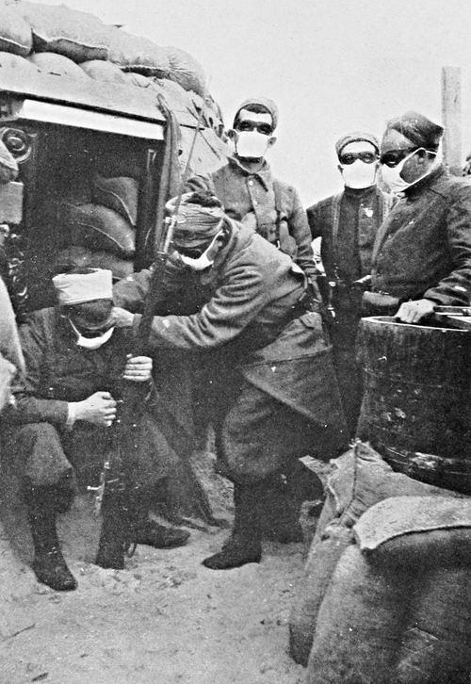
- 22nd April: At the Second Battle of Ypres, the Germans attack with poison _______ for the first time on the Western Front.
- 24th April: The Ottoman Empire begins the systematic deportation and murder of ethnic ________________ living within its borders. The Armenians are a long-persecuted ethnic and religious minority, suspected of supporting Turkey's enemies. left to die. In all, more than a million Armenians perish.
- 7th May: At sea, the British passenger-liner_______________________, sailing from New York to Liverpool, is torpedoed by a German U-boat off the coast of Ireland without warning. US President Woodrow Wilson and the American public are outraged.
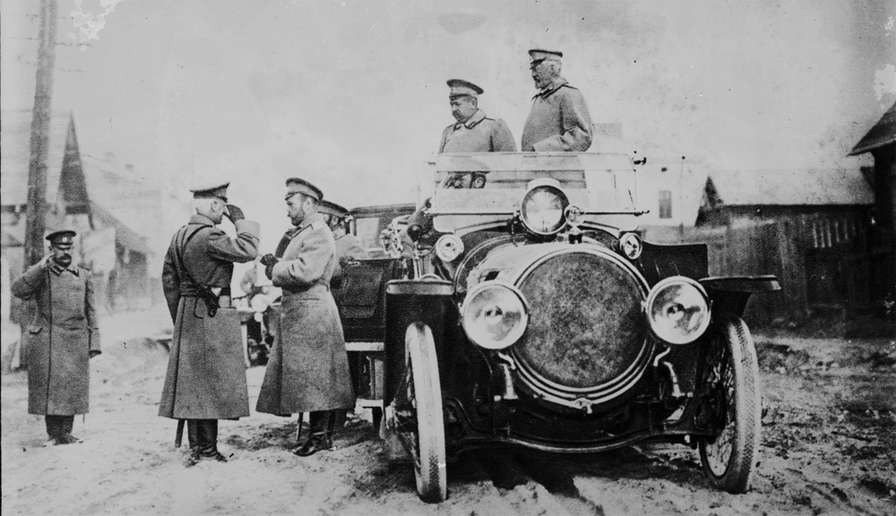
- 23rd May:Which alliance does Italy join? Central or Allied (circle the correct one)
- 1st September: In the Atlantic, a German U-boat sinks the liner SS Arabic: ____ are lost, including three Americans. In response to further US warnings, Germany ends all attacks on passenger ships.
- 3rd October: by the end of the war a third of __________ army has been killed – the highest proportion of any nation.
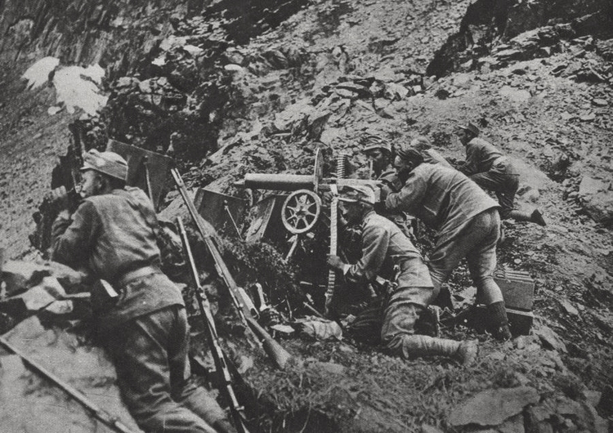
- 20th December: The Allies abandon the Gallipoli campaign. _____________ troops are secretly evacuated without alerting Turkish forces. Not a man is lost.
- Why is 1915 a bad year for the Allies? – enormous ________, for no tangible_______. .All sides still believe a decisive battlefield victory is within grasp.

