Drafting A
Introduction to CAD

Student Learning Guide

Student Name: ________________________________
Shapes
Shape 1  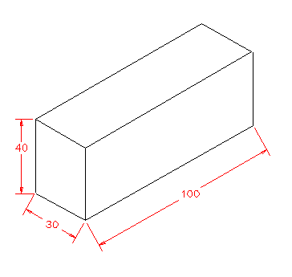 | Shape 2  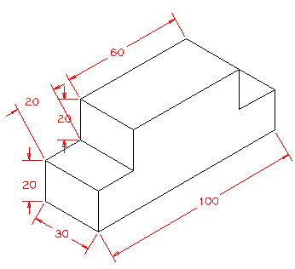
Shape 3  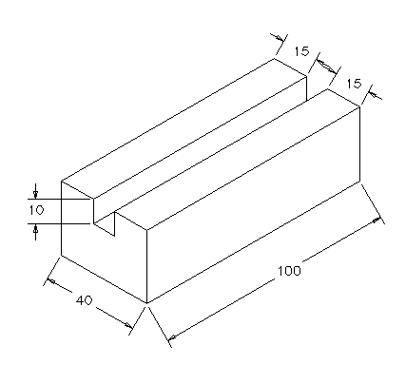  30 | Shape 4  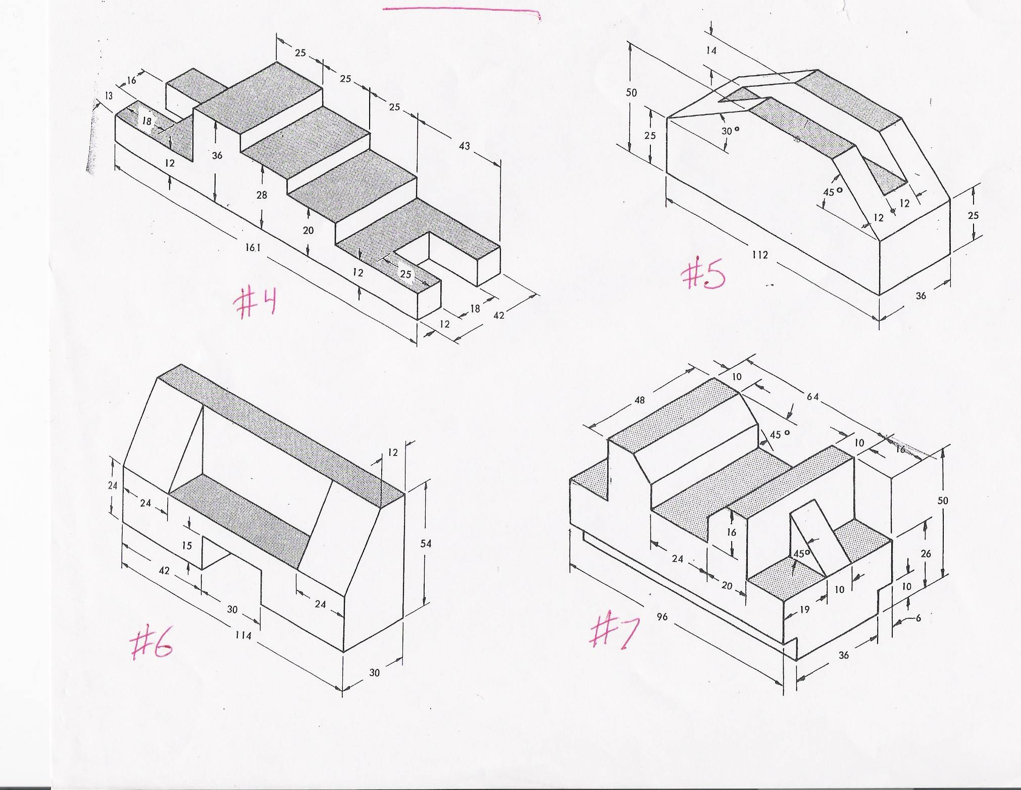

Shape 5  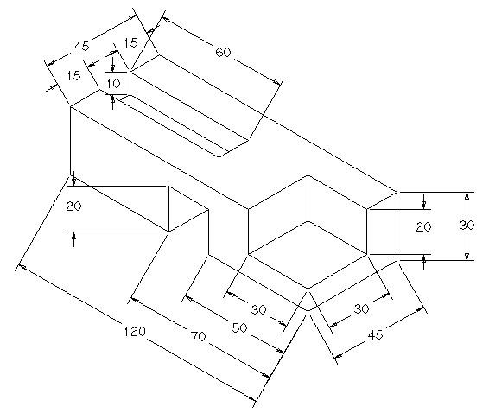 | Shape 6
Shape 7  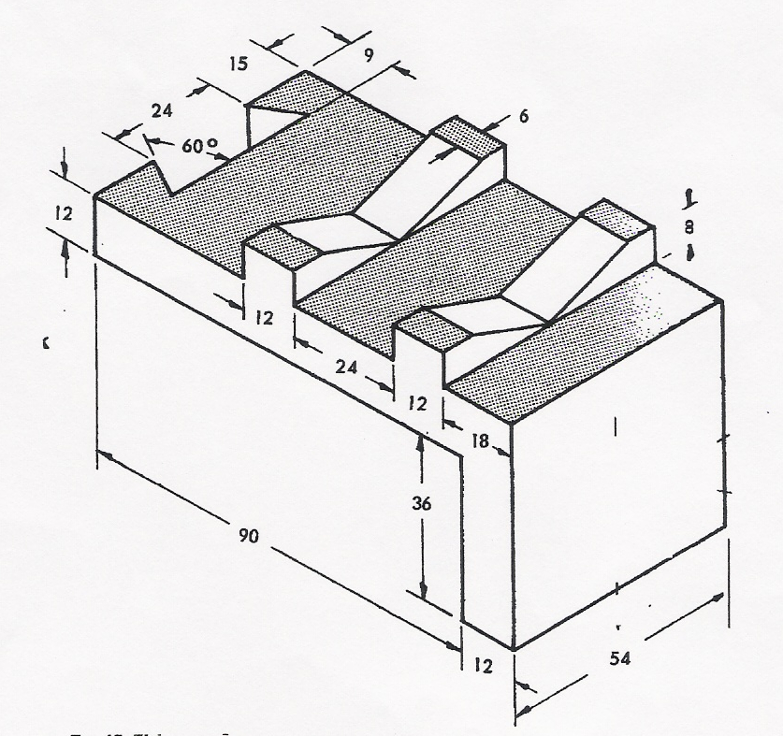 | Shape 8  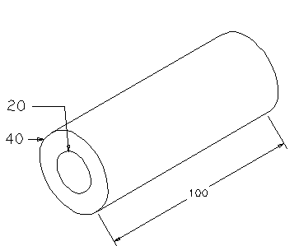

Activities Time Line
Student Name:____________________________

Class | Activity Number | Activity Name | Shape Number
1 | Video | CAD A Introduction
1 | Video | CadStd  Settings
1 | Video | CadStd  Draw Options
2 | Video | CadStd  Edit Options
2 | Video | CadStd  Window Options
2 | Video | Drawing a  Template
2 | 1 | Template
3 | Video | Drawing an Isometric Drawing
3 | 2 | Isometric 1 | 1
3 | Check Point Teacher Signature:__________________
3 | 3 | Isometric 2 | 2
3 | 4 | Isometric 3 | 3
3 | Check Point Teacher Signature:__________________
4 | Video | Drawing an  Oblique Drawing
4 | 5 | Oblique 1 | 1
4 | 6 | Oblique 2 | 2
4 | 7 | Oblique 3 | 3
4 | Check Point Teacher Signature:__________________
5 | Video | Drawing a  Cabinet Drawing
5 | 8 | Cabinet 1 | 1
5 | 9 | Cabinet 2 | 2
5 | 10 | Cabinet 3 | 3
5 | Check Point Teacher Signature:__________________

6-7 | 11 | Isometric 4 | 4
6-7 | 12 | Isometric 5 | 5
8-9 | 13 | Isometric 6 | 6
8-9 | 14 | Isometric 7 | 7
8-9 | Check Point Teacher Signature:__________________
10-11 | 15 | Oblique 4 | 4
10-11 | 16 | Oblique 5 | 5
12-13 | 17 | Oblique 6 | 6
12-13 | 18 | Oblique 7 | 7
12-13 | Check Point Teacher Signature:__________________
14-15 | 19 | Cabinet 4 | 4
14-15 | 20 | Cabinet 5 | 5
16-17 | 21 (Optional) | Cabinet 6 | 6
16-17 | 22 (Optional) | Cabinet 7 | 7
16-17 | Check Point Teacher Signature:__________________
18 | Video | Drawing Isometric Circles
18 | Check Point Teacher Signature:__________________
19 | 24 (Optional) | Cylinder | 8
20 | Exam (See Teacher)



