Creative Brief Assignment
What is a creative brief? A creative brief is a short 1-2 page document outlining the strategy for a creative project. Think of it as a map that guides a creative team on how to best get the campaign’s message across.
What is your campaign? The Canadian War Museum in Ottawa is setting up a new wing devoted to Canada’s role in the Second World War. You are tasked with writing the creative brief that will guide the construction of one display in this new wing.
These are the displays that will be set up in the new wing of the museum (choose one):
Canadian Navy  Canadian Air Force  Canadian Army  Dieppe Raid  Canadian Leadership (political or military) | Normandy Campaign  Liberation of the Netherlands  Canada’s Industrial Contribution  Contentious Objectors  Conscription Debate  Nuremberg Trials | Propaganda and Recruitment  Atomic Project  Diplomatic Role  Intelligence (SOE, Camp X, etc.)  Internment Camps  Paratroopers (Wismar)

Required Elements:
- Overview: A brief overview (background).
- Key Points: Key point(s) that you as the creator will attempt to highlight in the display.
- Primary Message: Primary message describing the value and contribution of the topic of study.
- Highlight: You should highlight one area to draw people in which will likely be at the centre of the display.
- Primary Source: At least two primary sources should be included with analysis.
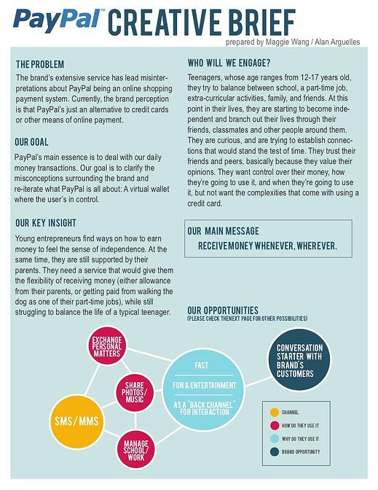
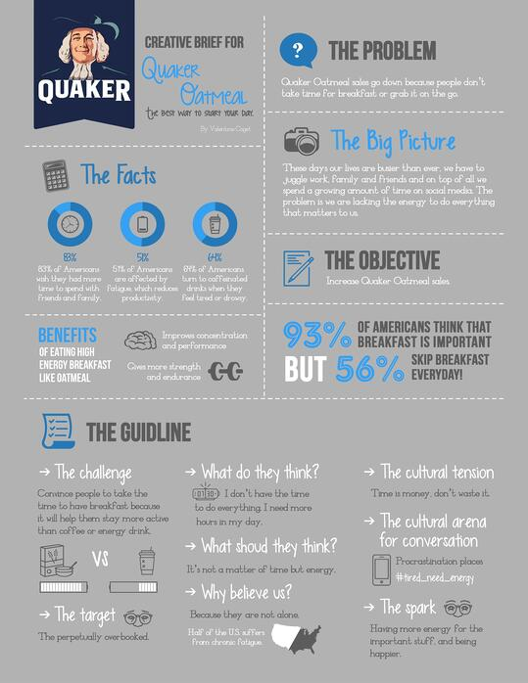
- Historical Significance: Explain the historical significance of your topic of study. Connect to present.

Rubric:
 | 9-10 | 7-8 | 5-6 | 4 or less
Required Elements | All required elements are included and stand out. | All required elements are included. | Most of the required elements are included. | Some of the required elements are included.
Historical Thinking: Primary Source and Historical Significance | All required elements are included and there is extensive analysis. | All required elements are included and there is analysis provided. | Most of the required elements are included with some analysis. | Most of the required elements and analysis are missing.
Canadian Connection | Each section of the brief makes a strong connection to the Canadian perspective and contribution. | Each section of the brief makes a connection to the Canadian contribution. | Most sections focus on the Canadian contribution but at times content provided is too broad. | Content provided is too broad and does not focus on Canadian connection.
Layout | The brief is organized, professional and creatively arranged. | The brief is organized and professional. | The brief is somewhat organized. | The brief is neither organized nor visually appealing.

