The Boer War
https://www.youtube.com/watch?v=ynBGT8rRaj0

Prime Minister Wilfrid Laurier was reluctant to get involved, and his divided Cabinet was thrown into crisis on the matter. Canada did not have a professional army at the time. Eventually, under intense pressure, the government authorized the recruitment of a token force of 1,000 volunteer infantrymen. Although they would fight within the British army, it was the first time Canada would send soldiers overseas wearing Canadian uniforms into battle.

- Why did Britain go to war against the Boers in present day South Africa?

- Who were the Boers?

- What makes the Boer War significant in the story of Canada?

- What made the war divisive in Canada?

- Describe the battle of Paardeberg?

- What is the legacy of the Boer War?

Look at the cartoon below and answer the questions that follow:

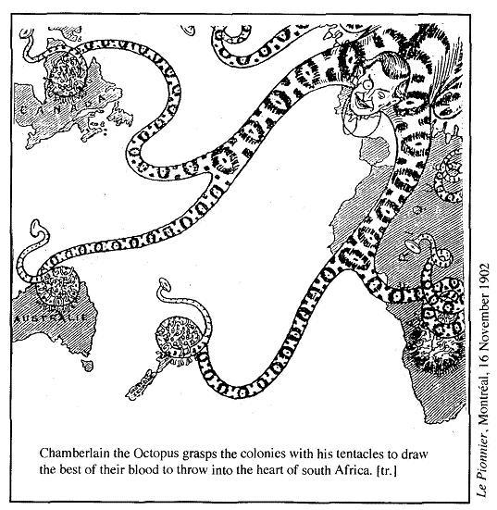

- What is the message the cartoon is attempting to get across?

- The cartoon is obviously critical of the war, where do you think most of this criticism came from?

