History 30 Essay
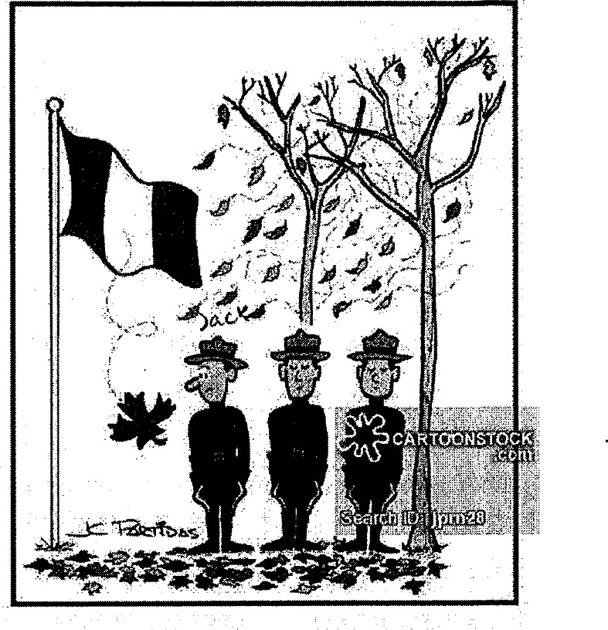
Question: Which of the following characters do you admire most -
John A McDonald, Georges-Etienne Cartier or George Brown?
In order to do a good job on this essay, it is imperative that you research each individual. We will be watching a movie, which will highlight all three Fathers of Confederation. It will be your job to jot down any points, which you deem important enough to add to your essay.
Format:
Introductory Paragraph - Thesis statement and introduction
1 ^{st} Paragraph - Explain why you admire the person. (ex. the way they conduct themselves, personality traits, etc.)
- ^{nd} Paragraph - Explain this individual's role in Confederation. (ex. explain their specific contribution(s) to Confederation)
- ^{rd} Paragraph - Explain the impact they have on today's society. (ex. explain how the country would be different without this individuals contributions.)
Concluding Paragraph – Restate thesis and wrap it up!

You will need to use at least one other source other than the video in conducting research for your essay. Both this source and the video must be listed in your Bibliography in Chicago-style formatting.

History 30 Rubric for Essay
 | Excellent | Average | Unsatisfactory
Thesis  Statement  (5 pts) | Thesis statement is clear, organized, specific, states a position and evokes discussion | Thesis statement is not clear, not organized, not specific, and/or does not take a position on the topic. | No evident thesis statement
Organization (5 pts) | Information is very organized with well-constructed paragraphs. Each paragraph has a topic or focus that relates back to the thesis. | Information is organized, but some paragraphs are not well-constructed and/or lack a strong connection back to the thesis. | The paper is disorganized and/or paragraphs do not have a focus, or relate bac
Evidence /  Details  (10 pts) | All of the evidence and examples are specific and historically relevant. Evidence proved clearly helps back up points made. | Evidence and examples are provided but lack specificity and/or relevance. | Evidence and examples are not relevant and/or are not explained. Or, paper lacks evidence and examples.
Analysis  (10 pts) | Evidence and details are thoroughly discussed and explained in order to demonstrate their relationship to the writer's thesis. | There is some discussion and/or explanation of evidence and details that support the writer's thesis. | Evidence and details are not discussed or explained.
Total Points: / 30

