Mini Bridge Project
Objective: Build a mini truss bridge with the best weight to strength ratio.
Step 1:
Complete some research into what gives a bridge the greatest amount of strength. You may use both the internet and print materials to complete this step.
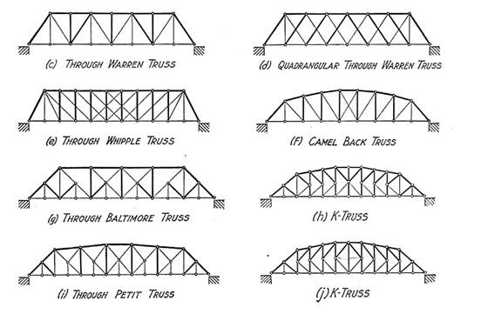
Step 2:
Create a scale drawing of your bridge.
Step 3:
Create your bridge in TinkderCAD. Make sure it is to scale. A bridge that does not meet the required dimensions will be rejected.
Step 4:
Export your completed TinkerCAD file to your instructor as an .stl file.
Step 5:
Your bridge will be tested in class. Your score will be calculated as follows:

# of pounds your bridge held | weight of your bridge | ratio
___________ (lbs.) / | ___________ (g) = | ____________

Mini Bridge Design Sheet

Design a bridge to meet the requirements below.
- SCALE drawing of the side view. Must be 7” or 178mm in length and have a height of 3” or 76.2mm. (All designs will be ¼” or 6.35 mm wide)

